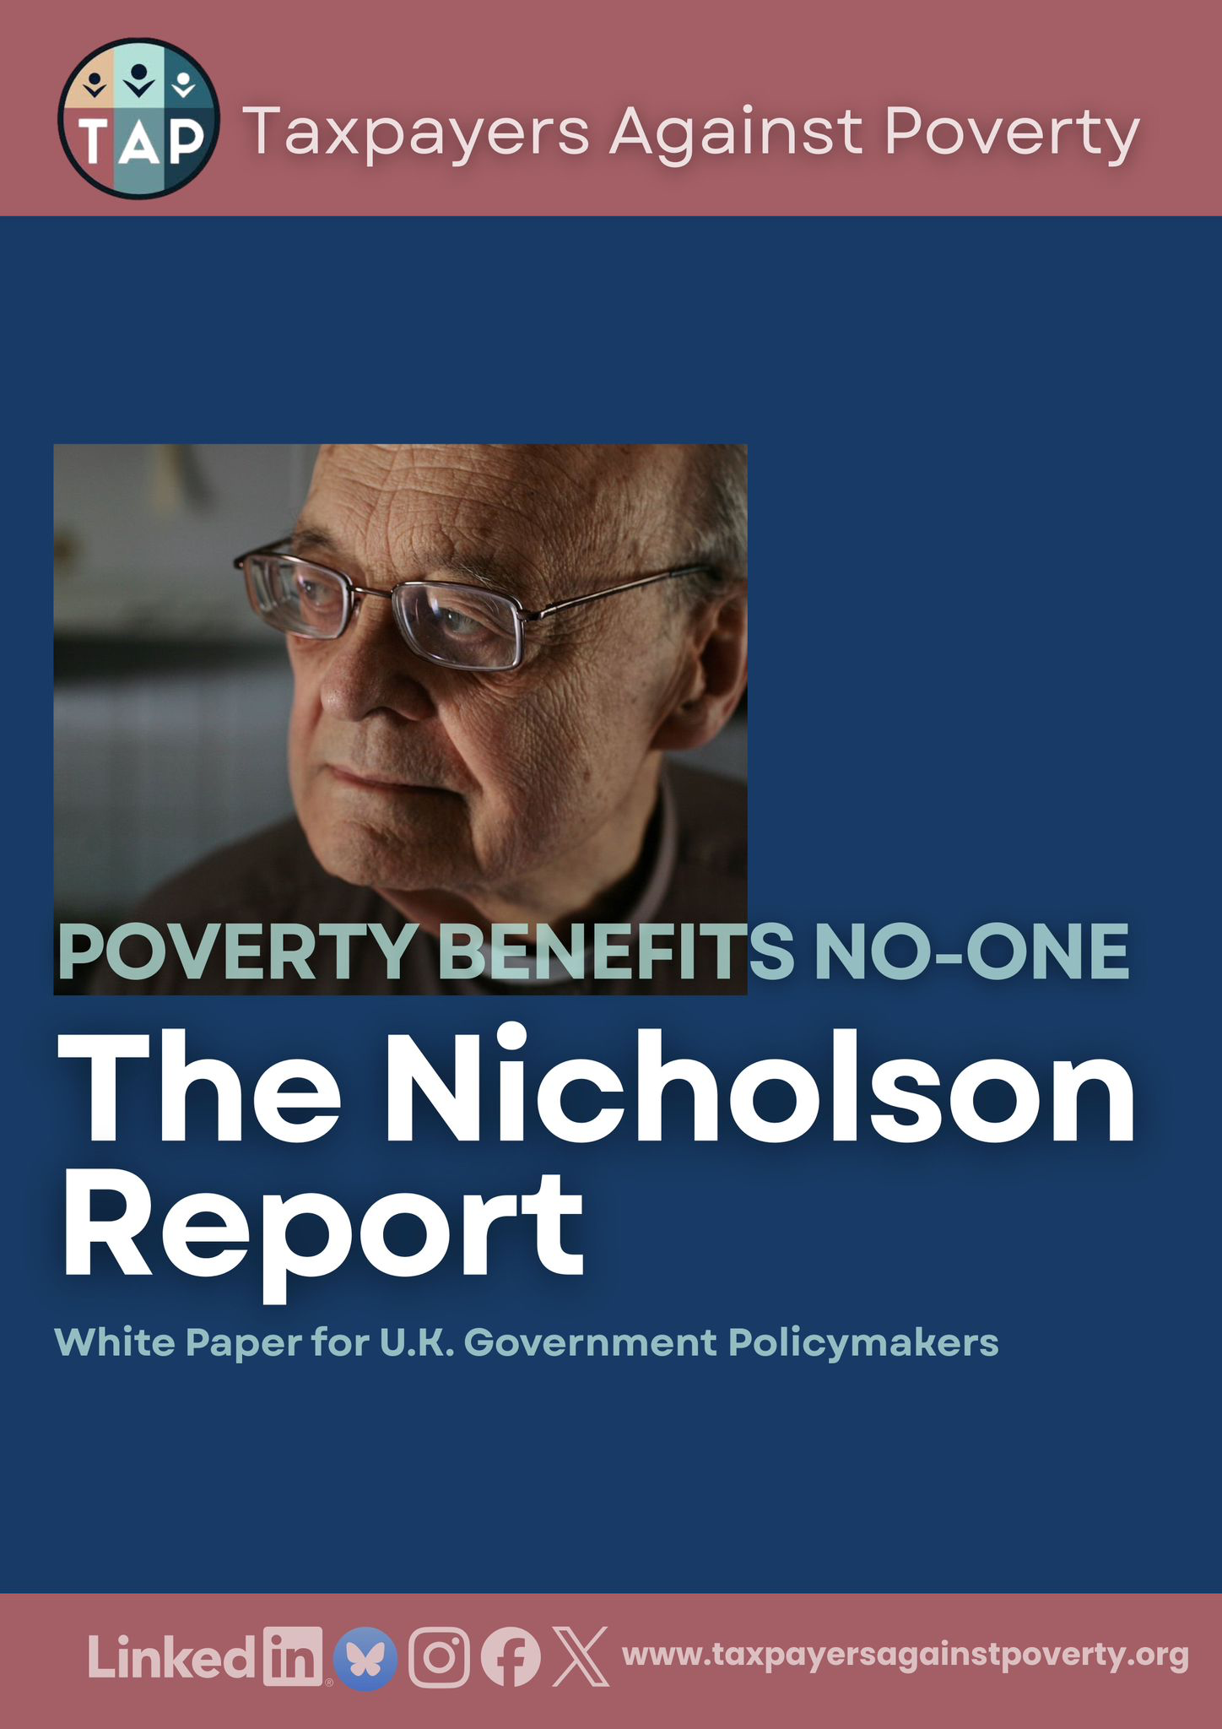

Foreword
This report is written in the shadow — and the spirit — of late Rev Paul Nicolson, the founder of Taxpayers Against Poverty.
Paul spent his life insisting on a simple, uncomfortable truth: that poverty in a wealthy country is not inevitable, and that allowing it to persist is a moral failure and an economic folly. He believed that public policy should be judged not by rhetoric or intent, but by its impact on the lives of the poorest. That conviction runs through every page of this report.
The Nicolson Report: The Poverty Scandal sets out the reality the UK now faces. Millions of people are living with unnecessary financial hardship. Families are pushed into insecurity not because resources are lacking, but because choices have been made — repeatedly — to tolerate a system that over-taxes work, under-taxes wealth, and under-invests in the public services and infrastructure that make prosperity possible.
This report is not about blame. It is about responsibility — and about evidence. Poverty benefits no one. It damages health, weakens productivity, increases pressure on public services and limits opportunity for the next generation. We all pay the price.
But the message of this report is also one of hope. Poverty is not inevitable. With a fairer and more modern tax system, and with sustained investment in education, health, social care and infrastructure, hardship can be reduced and prosperity shared more widely. Wealth in this country has been built on shared foundations. Those foundations now need renewing.
This report calls for bold and determined leadership — grounded in evidence, focused on outcomes, and willing to challenge comfortable assumptions. Ending the poverty scandal is not an act of charity. It is one of the most important economic choices the UK can make.
To readers of this report — policymakers, campaigners, taxpayers and citizens — the call to action is simple: do not accept poverty as inevitable. Question policies that deepen hardship. Demand fairness in how we raise and use public money. Support solutions that prevent poverty rather than manage its consequences.
Paul Nicolson believed that change begins when people refuse to look away.
This report asks you to do the same.
Tom Burgess
CEO, Taxpayers Against Poverty

The aim of this report by Taxpayers Against Poverty (TAP) is to reaffirm the severity of the problem and to recommend policies that will directly reduce poverty and inequality. TAP focuses on economic policies – especially tax reform – because we believe there is a direct connection between excessive wealth and poverty. The UK’s outdated tax system is making inequality worse. We therefore advocate for a complete overhaul and modernised tax system – as a matter of urgency. Government has a key role to play in showing leadership on these issues and to explain what can be done to end the poverty scandal.

Contents
- Executive summary
- Introduction
- Current poverty trends and affected populations
- Economic, social, and health costs of poverty
- The case for reforming welfare and tackling structural causes
- Place-based impacts and regional inequality
- Policy recommendations
- Conclusion

1. Executive summary
Poverty in the UK remains a widespread and pressing issue. Over one in five people (approximately 14.3 million individuals) were living in relative poverty after housing costs in 2022/23. This includes about 4.3 million children and 1.9 million pensioners, and these levels have remained stubbornly high in recent years.
In fact, the latest figures indicate child poverty has now risen to 4.5 million – the highest number in a generation. These statistics are a national scandal, and poverty at this scale is morally indefensible in a prosperous nation. An overwhelming majority of Britons are deeply concerned about rising hardship – 92% express concern about the cost-of-living crisis and expect action.
It is also economically counterproductive: new research suggests that protecting people from poverty and hunger could save the UK economy over £75 billion per year in avoided costs and lost productivity. In short, addressing poverty is both a moral imperative and a sound investment in the nation’s future.
Poverty benefits no one. Neither the individuals who experience hunger, insecurity, and ill-health, nor the broader society and economy. Children growing up in poverty often suffer lifelong consequences, from worse educational outcomes to poorer health, which in turn perpetuate cycles of disadvantage.
Workers in poverty (including many in low-paid employment) cannot contribute to their full potential, creating a drag on productivity and economic growth. Meanwhile, taxpayers shoulder billions in avoidable costs. For example, poverty-driven strain on the NHS and other public services costs tens of billions of pounds annually. The evidence is clear that investing in poverty reduction would yield substantial returns in improved public health, higher skills and productivity, and lower demand on welfare, health care, and emergency services.
Crucially, the current economic system contains structural injustices that exacerbate poverty. Chief among them is the way we tax income and wealth. The UK’s tax structure places heavier relative burdens on lower-income households (through taxes on earnings and consumption) while allowing vast accumulations of wealth to go largely untaxed, contributing to inequality and undermining poverty reduction efforts. As TAP’s CEO Tom Burgess points out, “our system over-taxes work and under-taxes wealth, and [thus] entrenches inequality.” Addressing poverty therefore requires not only stronger social support but also fairer fiscal policy that rectifies these imbalances.

Figure 5: Child Poverty by Ethnicity, 2024
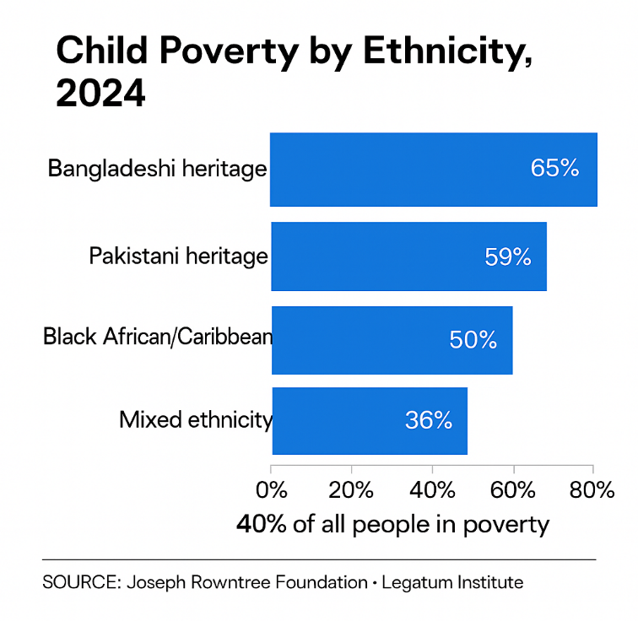

This report makes the case that tackling poverty in the UK is both morally necessary and economically smart. It outlines the current state of poverty – who is affected and how – and the heavy social and economic costs of inaction. It then presents a comprehensive strategy for change, grounded in evidence and human rights. Key recommendations include: ensuring work is a reliable route out of poverty by supporting secure jobs and fair wages; reforming social security so that benefits guarantee life’s essentials (for example, by ending policies like the two-child limit that push families into destitution); addressing regional inequalities with targeted investment in high-poverty areas; reforming the tax system to ensure the wealthy pay their fair share. For instance, by targeting unearned income and vast wealth that currently escape equitable taxation; and bolstering basic services such as affordable housing, childcare, and community support.
2. Introduction
Poverty in the UK is not just an economic statistic – it is a fundamental breach of our social contract and a threat to the nation’s future. In moral terms, the existence of mass poverty amid plenty is unacceptable. As TAP’s Chief Executive Tom Burgess puts it, “Poverty in a wealthy country is not inevitable — it is the result of choices.”
Even before considering policy details, the moral case for action is clear: no child should go to bed hungry or shiver in an unheated home, and no adult should have to choose between feeding their family and paying rent. Yet for too many in Britain, these are daily dilemmas. Public opinion reflects this moral urgency. An overwhelming majority of Britons believe that reducing hardship and tackling the rising cost of living should be top priorities for the Government. There is a broad consensus that something must be done to end the scandal of poverty amid plenty.
Beyond the ethical imperative, poverty undermines the very social and economic foundations of the country. A society where many cannot afford essentials cannot truly empower its people. Poverty and economic insecurity erode social cohesion and trust in institutions. Children who grow up in poverty often start life at a disadvantage. Some students arrive at school hungry or poorly dressed, which can hinder their education and future opportunities.
Communities with high poverty tend to experience higher crime rates, poorer health outcomes, and lower civic participation. In short, poverty’s effects ripple outward, weakening the social fabric that binds communities together.
Crucially, poverty is not just a social ill; it is also an economic deadweight. When a large segment of the population cannot participate fully in the economy – whether due to ill-health, lack of education, or inability to afford job search and training – the country’s productivity suffers. Research by the Trussell Trust and other experts quantifies this drag: hunger and hardship make it harder for people to secure and sustain employment, costing the economy an estimated £38 billion per year in lost productivity and lower workforce participation.
At the same time, poverty increases public expenditure in reactive ways. The government must spend billions more on healthcare, social care, temporary housing, and other services to address the fallout from poverty. The NHS, for example, incurs an additional £29 billion each year in costs associated with poverty (as of 2016), and subsequent analyses suggest this figure is likely even higher today – possibly £40–50 billion – given rising levels of hardship and health need.
Health experts have described poverty-related illness and untreated conditions in low-income communities as a “mounting catastrophe” for the NHS. Conditions like malnutrition, respiratory diseases from poor housing, and mental stress from financial insecurity all contribute to higher healthcare utilization. About a quarter of all spending in UK hospitals and primary care can be attributed to greater use by people in poverty.
Emergency services are stretched by the consequences of deprivation. A&E visit rates are almost twice as high in the most deprived areas, and emergency hospital admissions are 68% higher for the poorest groups compared to the wealthiest.
Such disparities illustrate how failing to prevent poverty effectively “taxes” the healthcare system. Alarmingly, the Department for Work and Pensions recently reported that 18% of children were living in households experiencing food insecurity – the highest level on record since the government began tracking it. This means millions of children are at risk of being too hungry or malnourished to learn and thrive, which in turn forebodes higher future costs in health and education.
There are also significant economic productivity losses associated with poverty. Individuals who grow up or live in poverty often face obstacles to obtaining education, training, and stable employment. Children who experience poor nutrition or high stress from an early age may struggle in school, affecting their skills development. Adults in poverty may find it harder to search for jobs or may have to accept precarious, low-paid work. All of this results in lost potential output.
The Trussell Trust estimates that hunger and hardship lead to about £38 billion in lost economic output annually because people are unable to secure or sustain employment at their full capacity. Additionally, poverty forces people to make short-term choices that undermine long-term productivity – for instance, skipping meals or healthcare to pay rent, which can worsen their health and employability.
Meanwhile, poverty also drags on public finances through reduced tax revenues and higher welfare payments. If people earn less (or not at all), they pay less in taxes and often need more support.
One recent analysis found that hardship and lower incomes lead to £18.4 billion in lost tax revenue and £5.3 billion in additional social security spending per year. In other words, poverty isn’t just painful for those experiencing it – it imposes a huge financial cost on society. As one study put it, failing to end hunger and hardship is costing the UK over £75 billion each year, a figure that dwarfs what it would take to significantly cut poverty through preventive investments.
In sum, addressing poverty is both the right thing to do and the smart thing to do. It is right because it aligns with British values of fairness, decency, and compassion. No one in the UK should be left destitute or without hope. And it is smart because investing in poverty reduction yields returns in the form of a healthier, better educated, more productive population.
As the Joseph Rowntree Foundation (JRF) notes, failing to act on poverty is ultimately self-defeating even for the Government’s own goals: “Growing poverty and insecurity are acting as a tightening brake on economic growth and opportunity in the UK, reducing children’s readiness for school and ability to learn, while driving up poor health and increasing pressure on the NHS.” In other words, poverty today is building up costs for tomorrow, whereas reducing poverty would unlock talent, improve public health, and spur consumer spending and growth.
3. Current poverty trends and affected populations
Official data show that poverty rates in the UK have plateaued at high levels, and in some respects, poverty has become deeper and more entrenched. Around 21% of the population lives in relative poverty (after housing costs), roughly the same proportion as before the COVID-19 pandemic. In 2022/23, this translated to 14.3 million people, including 8.1 million working-age adults, 4.3 million children, and 1.9 million pensioners.
Put another way, about one in five adults and nearly one in three children in the UK are in poverty. After some fluctuations during the 2010s, the overall poverty rate has remained stubbornly flat in recent years.

Figure 1. Child Poverty Rate in the UK (2000–2024)
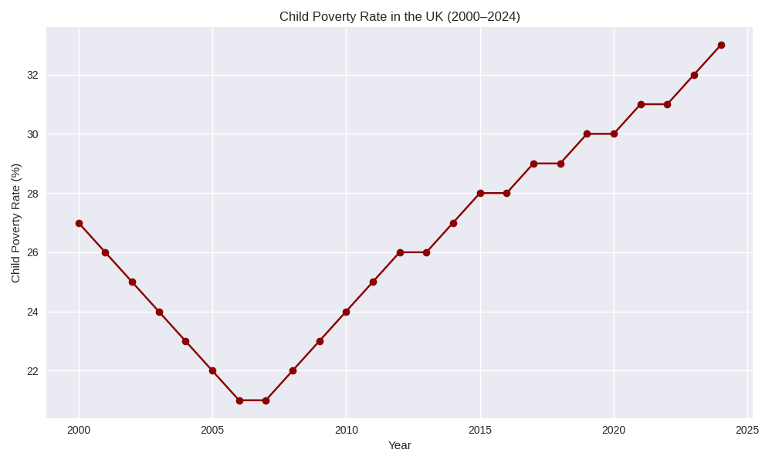
Source: Synthetic data based on trends reported by Save the Children (2025), The Orkney News (2025), and the Joseph Rowntree Foundation.
The last sustained reduction in poverty occurred in the early 2000s, and progress stalled thereafter. It has now been two decades without significant improvement in headline poverty levels. This long-term stagnation means that an entire generation has grown up with poverty affecting roughly the same share of the population, despite overall economic growth in the period. Alarmingly, within that static overall picture, certain dimensions of poverty have worsened.
Poverty has become more severe for many, and some groups face dramatically higher risks than others. The very latest figures (for 2023/24) confirm that there has been no meaningful progress: overall poverty remains around one-fifth of the population, and child poverty has in fact climbed to its highest level in 30 years (roughly 4.5 million children living in poverty, up from 4.3 million the year prior).
One concerning trend is the rise of deep and very deep poverty. These terms refer to households with incomes far below the poverty line (the poverty line is typically defined as 60% of median income). In 2022/23, approximately 6 million people – about 40% of all those in poverty – were in very deep poverty, with incomes less than 40% of the national median. This represents an increase in the share of poor people who are living at such extremely low-income levels.
The average person in poverty now lives 28% below the poverty line, a deeper shortfall than in the mid-1990s (when it was 23%). By the same token, destitution – the most extreme form of poverty, where people cannot afford even basic essentials like food, shelter or clothing – has been rising. JRF’s latest research found that around 3.8 million people experienced destitution in 2022, including about one million children. This figure has more than doubled since 2017, underscoring a troubling intensification of hardship at the very bottom of the income spectrum.
Figure 2: Deep and Very Deep Poverty in the UK, 2010–2024
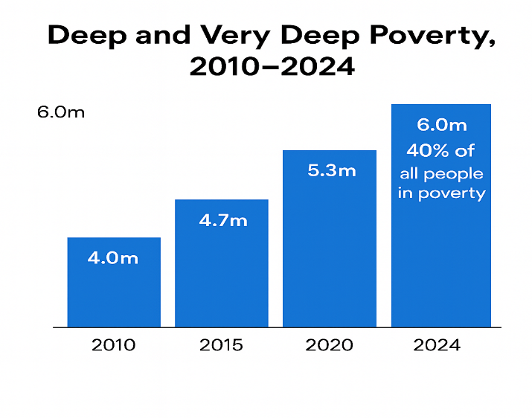
Source: Joseph Rowntree Foundation, (2025); Legatum Institute (2024)
In effect, not only has overall poverty persisted, but the poverty gap has widened. The poorest families are further below the poverty threshold than was the case a generation ago, and more people are experiencing outright destitution in one of the world’s richest countries.
Poverty in the UK is not evenly distributed. Some groups experience disproportionately high poverty rates. Children have a higher risk of poverty than the general population – about 30% of children were in poverty in recent years, compared to ~21% overall. Within that, children in larger families (with three or more children) face especially high poverty rates (around 45% in 2022/23) in part due to policies like the two-child benefit limit.
Indeed, nearly half of all children in poverty (49%) live in a household with three or more kids, showing how strongly the two-child cap and related cuts are driving child poverty. Lone-parent households and families with very young children also have elevated poverty rates. For example, 44% of children in lone-parent families, and 36% of children in families with a child under 5, were in poverty as of 2022/23. This reflects both lower earnings (due to childcare responsibilities) and policy gaps in support. Working-age adults without children have a lower poverty rate on average, but certain subsets (such as single young adults in low-wage work or on Universal Credit) face acute difficulties, especially with recent cost-of-living pressures.
Figure 3. Impact of the Two-Child Limit on Child Poverty (2024)
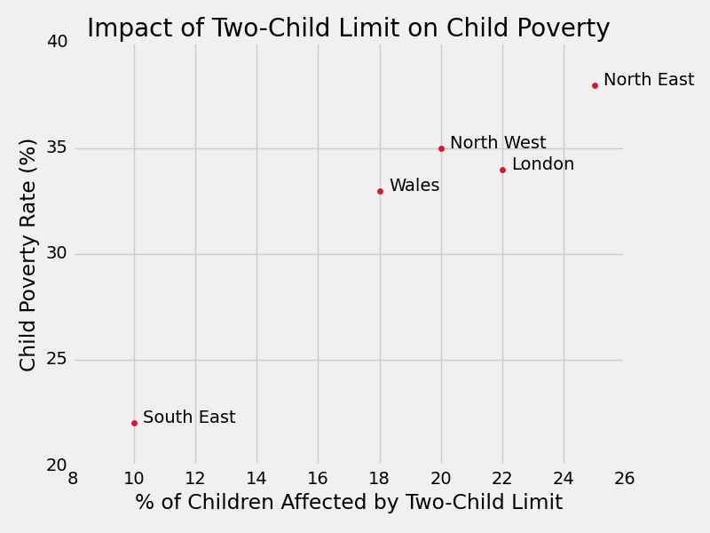
Figure Note: The two-child limit restricts benefit support for third and subsequent children, disproportionately affecting large families and contributing to regional disparities in child poverty.
Source: Synthetic data reflecting trends from Save the Children (2025), End Child Poverty Coalition, and Joseph Rowntree Foundation (2025).
Poverty is also markedly higher among certain ethnic minority groups. Recent data show that over half of people in Bangladeshi-heritage households (around 56%) and nearly half in Pakistani-heritage households (approximately 49%) live in poverty, compared to about 19% in White British households. The disparity is even more extreme for children. An estimated 65% of Bangladeshi heritage children and 59% of Pakistani heritage children are growing up in poverty, compared with 24% of White British children.
Poverty rates for Black households are also far above average. For example, around 40% of Black African or Black British individuals are in poverty, and roughly half of Black African/Caribbean heritage children are in poverty. These stark disparities are driven by factors such as unequal labour market outcomes, higher unemployment rates, differences in family composition, immigration status restrictions (e.g. the “No Recourse to Public Funds” policy affecting some migrants), as well as historic and ongoing discrimination. They highlight that poverty in the UK is tightly intertwined with racial inequality.
Households with a disabled person or someone with long-term health issues also have a higher poverty risk. About 30% of individuals in families where someone is disabled are in poverty, versus approximately 20% in households with no disabled members. Disability can increase living costs and reduce earning capacity, putting such households at greater risk of financial hardship. Among children, 33% of children in a household where someone is disabled are in poverty, compared to 29% in households with no disabled member – a gap that underscores the extra strain disability can place on family finances.
Workless households (where no adult is employed) unsurprisingly have very high poverty rates (well over half of such households are in poverty). Most people in poverty live in working households, highlighting the issue of in-work poverty. In fact, 72% of children in poverty have at least one working adult in their family. Low pay, insecure hours (zero-hour contracts, gig work), and inadequate wages relative to living costs mean that employment is not a guarantee against poverty for millions of families.
Finally, renters experience higher poverty rates than homeowners. About 44% of social renters and 35% of private renters are in poverty after housing costs, compared to roughly 10–14% of homeowners. High housing costs, especially in the private sector, push many low-income renters into poverty. In fact, for a large share of renting households, housing costs are the tipping factor that makes them poor.
These trends show that poverty is widespread but especially affects children, large families, certain ethnic minorities, disabled people, lone parents, and renters, with its severity worsening for those affected. This suggests that poverty is not simply a matter of transient misfortune for a small subset of people, but rather a persistent, structural problem affecting millions, often rooted in policy choices and systemic inequalities.
Figure 4. Poverty Rates by Demographic Group (2024)
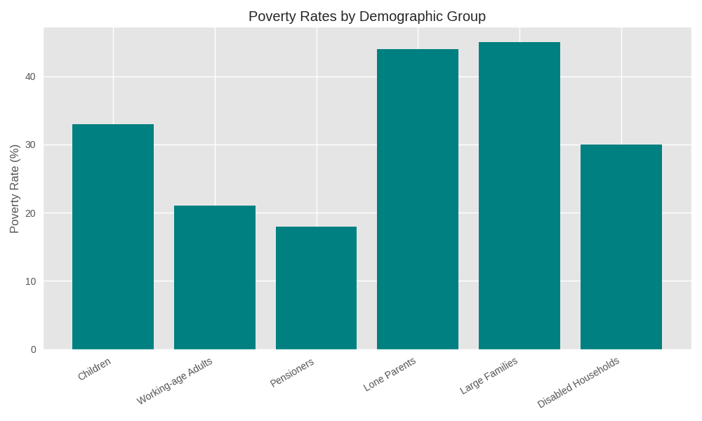
Figure Note: These disparities reflect both structural inequalities and policy-driven gaps in support, such as the two-child limit and inadequate disability benefits.
Source: Synthetic data based on trends reported by Save the Children (2025), Joseph Rowntree Foundation (2025), and Magic Breakfast (2025).
It also underscores that many of those bearing the brunt of poverty are the same groups who have historically faced disadvantage or discrimination, compounding concerns about fairness and social justice.
4. Economic, social, and health costs of poverty
Widespread poverty creates significant economic, social, and health costs for both those affected and society as a whole. Numerous studies have attempted to quantify these costs, and the findings are striking. As discussed, poverty and deprivation drive significant additional demand for public services. People in poverty are more likely to suffer ill-health and consequently place greater strain on the healthcare system.
A comprehensive study by JRF estimated that around £29 billion of NHS spending each year is associated with poverty (in 2016, equivalent to about one in every five pounds the NHS spends). Given rising levels of hardship and an aging population, this figure is likely even higher today – potentially £40–50 billion per year – representing a substantial portion of our national health budget.
Figure 5. Estimated Annual Economic Costs of Poverty in the UK
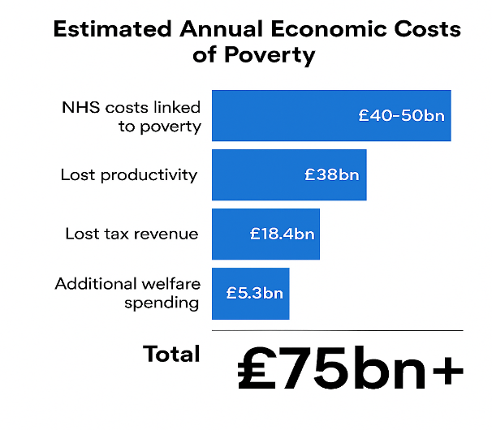
Source: The King’s Fund (2024); The Trussell Trust (2025), Joseph Rowntree Foundation (2025)
Health experts describe poverty-related illness and untreated health conditions in low-income communities as a mounting crisis for the NHS. Conditions linked to poverty such as malnutrition, diabetes, respiratory diseases from damp housing, and mental health issues driven by financial stress all contribute to higher healthcare utilization.
In fact, approximately a quarter of all spending in hospitals and primary care is attributable to greater needs among people in poverty. Emergency services feel this acutely. For example, A&E (emergency department) visit rates are nearly double in the most deprived areas, and emergency hospital admissions are 68% higher for the poorest groups compared to the most affluent. Such statistics translate into enormous costs that ultimately fall on taxpayers.
Beyond healthcare, poverty drives costs in other public services. Education systems spend extra resources to support children from low-income families who may arrive at school hungry, without proper clothing, or lagging in development. Schools in poorer areas often must devote funding to things like breakfast clubs or pastoral care that goes beyond education.
It is estimated that schools spend an additional £1.5 billion a year on initiatives like free school meals and pupil premium support for disadvantaged pupils – crucial help but essentially compensating for the effects of poverty on children’s readiness to learn.
Similarly, local authorities incur higher costs for social services and child protection in areas of high deprivation, and the criminal justice system faces greater demand (with poverty and inequality linked to higher crime rates). Housing homelessness services, mental health services, and community support programs all face heavier caseloads when poverty is widespread.
Poverty is also linked to considerable economic productivity losses. When individuals grow up in or live in poverty, they often face obstacles to obtaining education, skills, and stable employment. Children who experience poor nutrition or high stress from an early age may struggle in school, affecting their cognitive development and educational attainment.
Adults in poverty may have difficulty affording transportation, suitable clothing, or technology needed for job-hunting, or may find it hard to focus on skills training while dealing with day-to-day financial crises.
All of this results in lost human potential and output. Research by The Trussell Trust found that hunger and hardship lead to an estimated £38 billion in lost economic output annually due to people being unable to secure or sustain employment at their full capacity.
This lost output is essentially a drag on GDP – talent and labour that could have contributed to the economy is underutilized or wasted. Additionally, poverty often forces people to make short-term choices that undermine long-term productivity by, for instance, taking a survival job instead of training for a better career, or children leaving school early to support family income. Over time, these effects accumulate to lower the nation’s skills base and productive capacity.
Poverty also weakens consumer demand in the economy. Low-income households have minimal disposable income, which is typically used for necessities rather than discretionary purchases. This limits overall consumption and demand for goods and services. If millions of people’s incomes were lifted even modestly, that money would likely be spent in local economies – boosting businesses and, in turn, job creation.
Conversely, the current situation where many households cut back on everything (including basics like food or heating) means less money circulating in the economy and more businesses struggling for customers. For example, surveys in late 2024 showed that 69% of low-income households were going without essential goods and 54% were cutting back on food or going hungry due to the cost-of-living crisis. Such widespread belt-tightening is not only a human tragedy but also economically contractionary.
Finally, persistent poverty has intangible social costs. It erodes social cohesion and trust, fuels frustration and alienation, and can destabilize communities. Areas of concentrated poverty often suffer from higher crime and anti-social behaviour (born of desperation or lack of opportunity), which imposes both financial and quality-of-life costs on society.
There is also an intergenerational cost. Children raised in poverty are more likely to grow up to earn less and face health problems, perpetuating a cycle that prevents whole communities from thriving. This means that today’s inaction on poverty effectively “bakes in” lower economic outcomes and higher social spending for the future.
5. The case for reforming welfare and tackling structural causes
Poverty does not occur in a vacuum. While individual circumstances vary, there are structural forces and policy choices that largely determine the extent of poverty in a society. In the UK, a combination of an inadequate welfare system and certain structural injustices in the economy have allowed poverty to take root and persist.
Tackling poverty therefore requires both reforming the social security (welfare) system to provide a stronger safety net, and addressing the underlying drivers like wage inequality, high living costs, and an unfair tax system that often exacerbates inequality.
Over the past decade, a series of cuts and changes to the welfare system have weakened the UK’s anti-poverty protections. Benefits for working-age adults and families were repeatedly frozen or capped, even as rents and living costs rose.
Notorious policies such as the five-week wait for Universal Credit (UC), the two-child limit on benefits, the benefit cap, and the bedroom tax (spare room subsidy cut) have pushed thousands of households into hardship. Food banks, almost unheard of at scale 15 years ago, have become a widespread last resort for families who cannot make ends meet. The safety net that is supposed to catch people when they fall has grown threadbare.
At the same time, the labour market has seen a rise in low-paid, insecure work. Employment in the UK is high, but too many jobs are not paying enough to live on. The minimum wage (rebranded the National Living Wage for over-23s) has increased in recent years, yet about 3.7 million people remain in low pay (earning below a real living wage) and many more have unstable hours. Zero-hour contracts and gig-economy jobs mean incomes can be erratic. In-work poverty has reached record levels: as noted, most people in poverty belong to working households. The promise that “work is the best route out of poverty” is broken if work does not guarantee a decent living standard.
Housing costs are another structural driver. The UK has some of the highest housing cost burdens in Europe, especially in the private rental sector. In places like London, nearly half of those in poverty are only in poverty after housing costs are counted – meaning expensive rent is what pushes them over the edge.
Social housing (with its more affordable rents) has not kept up with need. The stock has dwindled and waiting lists are long. Housing benefit (now part of UC) is often insufficient to cover actual rents – Local Housing Allowance rates were frozen and even after a modest uprating in 2024, they remain inadequate in high-rent regions. For example, in London and the Southeast, many families face a shortfall of hundreds of pounds between their housing benefit and their rent, which they must cover out of meagre incomes, often by foregoing other essentials. This housing affordability crisis has fed directly into rising homelessness and poverty.
Regional inequality also plays a role. Certain regions – particularly parts of the North of England, the West Midlands, Northern Ireland, and Wales – have higher poverty rates than the national average. For instance, the Northeast of England and Yorkshire have seen poverty rates hover above 25% in recent years, compared to around 22% in the Southeast. These differences mean a child growing up in, say, Tower Hamlets in East London or in parts of Birmingham is statistically much more likely to experience poverty than one in Surrey or Oxfordshire.
Within regions, disparities can be even more granular. One ward of a city can have child poverty above 50% while a neighbouring ward is under 10%. Such intra-city and intra-region inequality often reflects concentrations of social housing or low-income communities in certain areas, while affluent communities might be just a mile away. Place-based economic decline – for example, former industrial towns with few new jobs – leads to pockets of entrenched poverty. Any national anti-poverty strategy must account for these spatial disparities.
A key structural injustice that TAP has highlighted is the way we tax income and wealth. The UK tax system, as it stands, tends to place a higher burden (relative to income) on those who earn wages and consume goods, while wealth-based taxation is comparatively low. For example, a nurse or builder pays substantial income tax and National Insurance on their earnings, plus 20% VAT on many purchases. Meanwhile, a billionaire investor may pay a lower tax rate on capital gains (or use loopholes to pay very little), and the owner of a £10 million mansion in London pays only marginally more council tax than someone with a modest home worth one-tenth of that value.
In some cases, analysis has shown that the poorest 10% of households pay a higher proportion of their income in total taxes than the richest 10% – a regressive outcome that most would find very unfair. This happens because taxes like VAT and council tax hit those with lower incomes hardest (they spend most of their income just to get by), whereas much of the income of the rich comes in forms that are taxed lightly or not at all (capital gains, assets that appreciate).
TAP believes this link between excessive wealth and poverty is direct: when vast wealth goes undertaxed, government lacks resources for anti-poverty programs, and inequality widens which can fuel higher living costs (e.g. house prices) and lower bargaining power for workers.
Put plainly, an economic system that “over-taxes work and under-taxes wealth” will tend to make the rich richer and leave the rest struggling – which is exactly what we have seen over recent decades.
It follows that truly tackling poverty will require structural reforms: repairing the social safety net, improving job quality and pay, building affordable homes, and modernising the tax system so that it promotes fairness rather than exacerbating inequality.
6. Place-based impacts and regional inequality
Place matters greatly in understanding and addressing poverty. The risk of being poor, and the experience of poverty, can differ dramatically depending on where one lives. The UK is a highly regionally imbalanced country – with a wealthy Southeast (London and surrounding areas) and pockets of prosperity elsewhere, but many other regions struggling with lower wages, higher unemployment, or higher living costs. Regional inequality in incomes and opportunities has been persistent for decades, and it translates into geographic disparities in poverty rates.
For instance, the latest data show that poverty (after housing costs) ranges from around 22% in the Southeast of England to roughly 27% in the North East and 29% in London. Some of the highest poverty rates are found in big cities and former industrial areas. London, despite its wealth, has a high poverty rate in part because of extremely high housing costs that squeeze low-income residents.
By contrast, some rural areas have lower headline poverty rates but may conceal hidden deprivation (and often face higher fuel and transport costs). Child poverty rates vary especially widely between nations. In Scotland, the child poverty rate is about 24%, significantly lower than in England (30%) or Wales (29%), and similar to Northern Ireland (approximately 23%). This divergence has grown in recent years, likely due in part to policy differences.
Within England, the northeast and parts of the north-west have some of the highest poverty levels. By contrast, the southeast (outside London) and east of England have lower rates (though still significant pockets of poverty). Local-level differences are often stark. Even within one city or county, one neighbourhood can suffer intense deprivation while a nearby area is relatively affluent. For example, in cities like Manchester, Birmingham, or Glasgow, one ward might have child poverty rates above 50% while a neighbouring ward has rates under 10%. These juxtapositions underscore that poverty can be highly concentrated, often correlating with areas that have faced economic decline, factory closures, or historically were centres of lower-paid industries.
Place-based factors that contribute to poverty include the availability (or absence) of good jobs, the cost of living locally (especially housing and transport), and the level of local resources/support. In parts of the country, secure jobs with decent pay are scarce – and those regions often see more people either unemployed or forced to take whatever low-wage work is on offer.
Some coastal towns, for example, have very high unemployment and seasonal, low-paying jobs dominating, leading to entrenched poverty. Remote rural areas might have cheap housing but also have fewer jobs and require expensive travel (or needing a car due to poor public transport), adding another burden on residents.
All of this means that place-based policy is crucial. A national strategy must recognize that one size does not fit all. High-poverty regions likely need targeted economic development. For instance, public infrastructure projects, incentives for businesses to set up operations there, and investment in education and skills targeted at local industry needs. They may also benefit from devolution of powers and funding, allowing local authorities or devolved governments (in Scotland, Wales, Northern Ireland, and city-regions in England) to design and implement anti-poverty initiatives suited to their context.
In fact, we see some divergence already. Scotland and Wales, for example, have used devolved powers to introduce measures like the Scottish Child Payment (a direct child benefit for low-income families) and more generous Council Tax reduction schemes, which have helped mitigate poverty locally. English localities have fewer independent powers, but some city regions with metro mayors have experimented with innovative approaches (e.g. Manchester’s focus on homelessness with the Housing First pilot, or London providing free school meals to all primary pupils).
It is also worth noting that regional inequalities intersect with other factors Ethnic minority populations in the UK, for example, are disproportionately located in urban areas (London, West Midlands, Northwest), so the higher poverty in those regions also ties into the racial disparities discussed earlier. Likewise, the North of England and parts of the Midlands have older industrial economies and aging populations, implicating generational dynamics as well. In some former mining or manufacturing towns, an entire generation may have grown up with limited local opportunities, fuelling a cycle of out-migration of talent and further economic stagnation.
7. Policy recommendations
Eradicating or greatly reducing poverty in the UK is an ambitious but achievable goal, provided there is a concerted, cross-sector effort and the political will to implement evidence-based solutions.
Below is a set of policy recommendations aimed at UK policymakers. These recommendations are grounded in the data and analysis presented above, and importantly, they are intended to be practical and non-partisan – focusing on common-sense measures that could be supported across the political spectrum to ensure poverty truly “benefits no one.”
The overarching ethos is to combine immediate support to alleviate current hardship with long-term investments to prevent future poverty, all while maintaining fairness and opportunity for all.
Guarantee the essentials – restore adequacy to social security
Establish a welfare income floor (“Essentials Guarantee”) to ensure everyone can meet basic needs. This means uprating Universal Credit and related benefits to more realistic levels based on independent benchmarks like the Minimum Income Standard (which reflects the actual cost of a basic basket of goods).
As part of this, abolish policies that arbitrarily undermine adequacy and fairness, notably the two-child limit and the overall benefit cap. Removing these caps would immediately lift tens of thousands of children out of deep poverty and ensure families are not pushed into destitution by rules that do not account for genuine need. Any short-term savings these policies provided are far outweighed by the harm they cause.
A reformed social security system should ensure everyone can afford life’s essentials, with benefit rates that rise automatically with the cost of living (to prevent erosion during high inflation) and that safeguard human dignity. Additionally, end punitive design features like the five-week wait for Universal Credit (addressed further below under safety nets) and improve access to hardship grants. Social security should truly be a safety net and springboard, not a tightrope over poverty.
Make work pay and be rewarding
Strengthen employment as a reliable route out of poverty by enhancing both wages and in-work support. Continue raising the National Living Wage toward a real Living Wage for all age groups and enforce it. At the same time, reform Universal Credit to improve work incentives: increase work allowances (the amount low-income workers can earn before benefits start to taper off) and reduce the taper rate, so that workers keep more of each extra pound earned.
For example, lowering the UC taper (currently 55%) would boost take-home pay for low earners, as recommended by anti-poverty charities. Address insecure and low-hour work by promoting more stable contracts and extending full worker rights (sick pay, holiday pay) to gig economy and zero-hour workers.
Also invest in training and upskilling targeted at low-wage workers, enabling progression to better-paid jobs. The principle is that full-time work should provide a dependable escape from poverty, and part-time work or second earners should not be penalized by steep benefit withdrawal.
Making work pay also means stronger enforcement of labour standards (against things like wage theft or unsafe conditions) and supporting job creation in disadvantaged areas (see regional job investment below). The Government should also lead by example, ensuring all public sector and government-contracted jobs pay at least the real Living Wage. Work must once again guarantee a decent living standard.
Boost support for families with children
Children are our future, and no child should grow up in destitution. Increase financial support for families by substantially raising Child Benefit or introducing a new child poverty supplement, with extra help for larger families (to compensate for removing the two-child policy’s penalty) and for the early years of a child’s life.
The success of Scotland’s Scottish Child Payment – which provides £25 per week per child for low-income families and is projected to significantly reduce child poverty – shows the impact that direct cash support can have. Implementing a similar approach UK-wide (or boosting Child Benefit by an equivalent amount) would alleviate child poverty and improve children’s life chances. Alongside direct income support, expand access to affordable childcare.
Building on recent commitments, ensure free childcare entitlements cover more ages (including under-3s) and are funded adequately so that supply meets demand. High childcare costs currently trap many parents (especially single parents and mothers) in poverty or out of the workforce. Removing this barrier by providing free or heavily subsidized quality childcare yields a double dividend. It reduces poverty in the short term (by allowing parents to work) and improves outcomes for children long-term (by supporting early development). Ultimately, the aim is to make the UK a country where no child’s potential is blighted by lack of resources in their family.
Support unpaid carers and people with disabilities
Recognize and reduce the financial penalty faced by those who cannot work or can only work limited hours due to caring responsibilities or disabilities. Increase Carer’s Allowance and related caregiver benefits to better value the enormous contribution of informal carers and relax earnings limits so carers can earn a bit more without losing support.
For disabled people, ensure disability benefits (such as Personal Independence Payment) truly cover the additional costs of living with a disability. This may involve raising benefit levels and simplifying the often-onerous assessment processes so that people are not left for months without support.
The fact that the poverty rate for disabled adults is around 30%, and a shocking 50% for those with serious mental health conditions, indicates that the current support is insufficient. Consider introducing a dedicated “disability cost supplement” or increasing the Universal Credit Limited Capability for Work elements to address this gap.
Also, do no harm. Proposed cuts or restrictive reforms to disability support (such as moving people off certain benefits without adequate replacement) should be halted, as analyses warn they would push even more people into hardship. Instead, any welfare reforms for disabled people should be co-designed with disabled groups and aim to improve livelihoods – by, for example, integrating better employment support with health support for those who can and want to work, while guaranteeing a decent income for those who cannot.
Society owes a duty of care to those who face extra challenges; poverty should not be added to the burdens of disability or caregiving.
Ensure housing affordability and security
Make housing a platform for stability, not a driver of poverty. Take bold action to address the largest expense in most low-income households’ budgets: housing.
First, unfreeze and uprate Local Housing Allowance (LHA) to cover at least the 30th percentile of local market rents, and commit to keep it indexed to rent inflation going forward.
This would ensure that low-income private renters are not forced to cover large shortfalls between their housing benefit and their actual rent – a gap which currently pushes many into debt or out of their homes.
Next, invest in a major expansion of social and genuinely affordable housing. The government should support councils and housing associations to build hundreds of thousands of new social rent homes, particularly in high-need areas (e.g. cities and towns with high homelessness and very expensive rents).
Increasing the supply of affordable homes would, over time, reduce the housing benefit bill (since fewer people would need to rent at high private rates) and provide low-income families with the stability of a secure tenancy and reasonable rent. It would also create jobs in construction and related industries.
In the private rental sector, strengthen tenant protections: implement stronger rent regulation (for instance, caps on rent increases within tenancies, as Scotland has piloted) and abolish “no-fault” evictions (as has been done in Scotland and promised – though not yet delivered – in England). These measures would reduce the chance of sudden homelessness or displacement and help moderate rent inflation.
Ensure that a right to adequate housing is embedded in policy – meaning habitability, affordability, and security are treated as enforceable standards. Nobody should be pushed into poverty due to where they live.
Finally, expand and adequately fund homelessness prevention programs (like tenancy sustainment support, Housing First programs for rough sleepers, and emergency rent assistance). The cost of preventing homelessness is far less than the cost – human and financial – of responding after people lose their homes.
By treating housing as essential infrastructure and even a human right, the UK can eliminate the sad reality of families having to choose between paying the rent and feeding their children.
Strengthen the safety net and crisis support
Even with more adequate benefits and higher incomes, life will always have shocks – a job loss, a sudden illness, an unexpected bill or family emergency. It is crucial to have a robust safety net for those moments so that a short-term setback does not spiral into long-term poverty.
To that end, end the five-week wait for Universal Credit by providing an initial grant or an immediate interim payment when a person first files a claim. For example, the first UC payment could be made after two weeks as a partial advance (non-repayable for those with little to no savings), or a starter payment could be given to bridge the gap. This single reform would prevent thousands from falling into rent arrears or high-interest debt at the very start of a welfare claim.
Next, improve access to Local Welfare Assistance for emergency needs. Central government should ring-fence funding for local councils to run effective crisis support schemes (grants or in-kind help for people facing emergencies). Many areas’ local welfare funds have dwindled or disappeared in recent years; a dedicated funding stream would revitalize this “last line of defence” against destitution.
Similarly, expand support for community-led hardship assistance – boost funding for food banks, fuel voucher programs, and advice centres – while keeping the long-term goal of making charity-based aid largely unnecessary by fixing systemic issues. Debt relief should be part of the safety net: people overwhelmed by unavoidable debts (like government debt for benefit overpayments, council tax arrears, or utility debt) should have access to write-offs or manageable repayment plans that do not leave them in perpetual hardship.
Overall, ensure that if someone hits a rough patch, they are met with support, not sanctions or indifference. Quick, compassionate intervention can prevent a temporary crisis from turning into entrenched poverty.
Promote saving and fair credit
Financial resilience – even a small savings cushion – can make the difference between a setback and a catastrophe for a low-income family. Government can help build this resilience. Expand or introduce matched savings schemes for lower-income workers (similar to the successful “Help to Save” pilot, where the government matched 50p for each £1 saved, up to a limit). Such schemes provide an incentive for families to set aside a little money regularly, with a reward that boosts their savings.
Even a few hundred pounds in the bank significantly reduces the risk of falling into poverty after an income shock. At the same time, ensure the availability of fair, low-cost credit alternatives to high-cost payday lenders. This can include scaling up no-interest loan programs (which have been piloted) for people who cannot access mainstream credit and supporting credit unions and community development finance institutions to grow in underserved areas (perhaps through seed funding or partial loan guarantees). The goal is to offer people a way to borrow for essentials (like a broken appliance or car repair) without incurring punishing interest that traps them in debt.
Furthermore, integrate financial education and free debt advice into community services. When individuals face financial troubles, they should easily find help to navigate options (such as consolidating debts, claiming benefits, or accessing grants).
By boosting precautionary savings and access to fair credit, we can reduce the prevalence of crisis situations where one shock leads to spiralling debt and poverty.
Reform and modernise the tax system for fairness
It is often said that budgets reflect values and how a nation raises revenue is as important for poverty and inequality as how it spends. The UK should fundamentally restructure parts of its tax system so that those with the broadest shoulders contribute a fair share, while alleviating tax burdens that fall disproportionately on the poor.
This can include several measures:
Make local taxation more progressive
The current Council Tax system is outdated and regressive. In the medium term, the UK should replace Council Tax with a Proportional Property Tax or Land Value Tax (LVT), where owners pay based on up-to-date property values or the land’s value, respectively. This would shift the tax burden toward those with more valuable properties and land – and relieve some pressure on those in cheaper housing (often the less wealthy).
It would also capture some of the windfall gains from rising land values. In the interim, steps can be taken to make Council Tax fairer such as revaluing properties (the bands are still based on 1991 house prices) and add new higher bands for high-value properties, so that, for example, a mansion worth £5 million pays far more than a house worth £150,000 (currently it might pay only a little more).
Also, mandate more generous Council Tax Reduction schemes for low-income households, so that inability to pay does not translate into debt. Ultimately, landlords and property owners should bear a fairer share of local taxation, rather than low-income tenants being chased by bailiffs for a tax they struggle to afford.
The practice of sending vulnerable people to court or even prison for council tax arrears is inequitable and should end. As TAP argues, “Council tax is outdated, regressive, and wrongly targets those who don’t own the asset being taxed.” We need to rebalance local taxes to ease the load on the poor and ask more of wealthier property owners.
Tax extreme wealth and unearned income
Implement a modest tax on extreme wealth. For example, an annual levy on net wealth above £10 million would affect only the very richest but could raise substantial revenue. Analysis indicates that a small tax on fortunes over £10m could raise in the order of £20–25 billion a year.
Crucially, such a levy would not change the lifestyles of the wealthy (it is a tiny fraction of their assets), but it would generate funds that could be reinvested in society – funding affordable homes, better schools and childcare, stronger health and social care, and so on. Taxing wealth isn't punishment; as TAP states, it is a responsibility to reinvest collective gains for the benefit of everyone.
In addition, address major gaps in how different kinds of income are taxed. A concrete step is to equalise Capital Gains Tax (CGT) rates with Income Tax rates. Right now, someone living off investments can pay a lower tax rate on their capital gains than a nurse or teacher pays on their salary – which is hard to justify.
Aligning these rates (and reducing overly generous CGT allowances) would raise in the order of £15 billion a year and remove an incentive for the very wealthy to disguise income as capital gains. It is a matter of basic fairness that work should not be taxed more heavily than wealth. Similarly, apply National Insurance contributions to investment income (such as dividends, rent, interest), which could raise another £8 billion (approximately) and further level the playing field.
In short, those who live off wealth should contribute at least the same tax rates as those who live off work.
Reform inheritance tax to tackle entrenched inequality
Inheritance Tax (IHT) in its current form is paid by relatively few estates and is often legally avoided by the very richest through loopholes. Rather than scrapping IHT, the policy should be to strengthen it in a progressive way.
One idea is replacing the current estate tax with a lifetime gifts tax – taxing the total amount an individual inherits over their lifetime above a generous allowance – which would encourage wealth to be spread out and be harder for dynastically wealthy families to dodge.
In the immediate term, the government should close loopholes like the Business Property Relief and Agricultural Property Relief, which are meant to protect family farms and businesses but are being exploited by the ultra-wealthy to shield large assets from tax.
Inheritance tax should focus on fairly taxing large inheritances that contribute to inequality, while still allowing reasonable gifts to children within generous limits.
Reform regressive tax subsidies
A starting point cold be, for example, adjusting pension tax relief, which mainly benefits high earners. Upfront tax relief on pension contributions costs the Treasury tens of billions per year, yet most of that benefit accrues to people in the top income brackets who can afford to save the most.
As Parliament’s Treasury Committee noted, the current arrangements for pension tax relief are highly regressive, especially benefiting the top earners. Moving to a flat-rate relief (say 30% for everyone) or otherwise capping the subsidy to the very rich would make the system fairer and could save several billion pounds that could be redirected to support poorer pensioners or other priorities.
Ending the anomaly that allows some very high earners to get more than 40p in the pound in combined tax relief and NI exemptions on pensions is not about punishing success. It is about not subsidising already-advantaged individuals disproportionately.
Crack down on tax avoidance and evasion
Close loopholes and special regimes that enable some wealthy individuals and corporations to pay far less than their fair share. For instance, abolish or reform the non-domiciled (“non-dom”) tax status, which currently allows some UK residents to avoid tax on overseas income. Recent studies have found that taxing the worldwide income of non-doms could raise over £3 billion a year.
More broadly, invest in HMRC’s enforcement capacity to target aggressive tax avoidance schemes, strengthen transparency (country-by-country reporting for multinationals), and cooperate internationally to tackle tax havens. When the wealthy and big companies pay what they owe, it not only raises revenue but also promotes a sense of common sacrifice and trust in the system – people see that it’s not only the salaried middle-class and the poor who contribute, but also those with the greatest ability to pay.
Together, these tax measures would generate significant revenue that can fund anti-poverty programs Perhaps even more importantly, they rebalance the distribution of financial burdens in Britain. When the wealthy pay a bit more in line with their capacity, and the poor pay less, the outcome is a more equitable society with less extreme inequality – one where poverty is less likely to occur in the first place.
A fair tax system is thus a foundation for a fair economy. Notably, these reforms can be done while maintaining the UK’s economic competitiveness and without harming growth. In fact, excessive inequality itself can impede growth and stability over the long term.
By taxing income from wealth on par with income from work, and by ensuring owners of expensive properties and great fortunes contribute appropriately, the UK would follow the principle that everyone should help fund the common good according to their ability. As TAP argues, the tax system should not be structured in a way that “makes the poor poorer” – rather, it should seek to reduce poverty and inequality even as it raises revenue.
Monitor progress and enforce accountability
Adopt clear poverty-reduction targets and establish mechanisms to ensure government is held accountable for outcomes. For instance, reinstate a form of national poverty target (similar to ethnicity the previous target of ending child poverty by 2020, which, while ultimately missed, helped focus minds and coordinated action).
The government could commit to reduce the child poverty rate to single digits within a decade, or to eliminate destitution by a certain year. These targets should be accompanied by annual reporting to Parliament on poverty trends across various measures (relative poverty, absolute poverty, material deprivation, and destitution) and across different groups and regions.
Transparency will help maintain pressure and public attention, especially when progress stalls. In addition, consider establishing or empowering an independent body – akin to a Social Justice Commission or an expanded Social Mobility and Child Poverty Commission – to scrutinize government policies and recommend course corrections.
This body could produce an annual “state of the nation” report on poverty and inequality, providing expert analysis on whether current efforts are sufficient.
Furthermore, enforce the Socio-Economic Duty (Section 1 of the Equality Act 2010) in England (it is already in force in Scotland and Wales). This duty requires public authorities to actively consider how their decisions can reduce inequalities linked to socio-economic disadvantage.
Implementing it in England would embed poverty-conscious policymaking across local councils, government departments, and other public agencies – meaning, for example, when a council develops housing plans or a school allocates pupil-premium spending, they must factor in how it will impact poorer communities.
By hard-wiring accountability and scrutiny into the system, we can ensure that tackling poverty remains a priority not just in rhetoric but in results.
Conclusion
TAP’s stance is direct. Poverty in a wealthy country is a policy failure and eliminating it is a policy choice. The UK can and should choose to end the poverty scandal. This report has laid out how – through pragmatic, fair, and forward-looking policies.
Implementing this agenda would ensure that no one in Britain has to suffer the indignity and hardship of poverty, and in doing so, we would build a stronger economy and a healthier society for everyone.
This is not the full picture – but it is a strong start. If we are bold, determined, and work together, we can reduce poverty and build a fairer society. History will judge this generation by whether we had the vision and compassion to end poverty amid plenty. With the ideas and momentum now in hand, it is time to act decisively. Poverty benefits no one – and ending it benefits us all.

The Orkney News. Unacceptably High Levels of Poverty in the UK. 30 January 2025.
Save the Children. 4.5 million children now living on poverty is a source of national shame. 27 March 2025.
Save the Children. 4.5 million children now living on poverty is a source of national shame. 27 March 2025.
The Health Foundation. Public perceptions of health and social care: what the new government should know. September 2022.
The Big Issue. Save tens of billions in public money by ending hunger – not slashing benefits, government told. Isabella Mcrae. 30 April 2025.
Taxpayers Against Poverty. Tax Wealth, Not Poverty – The key to inclusive growth. Tom Burgess, CEO Taxpayers Against Poverty. 7 October 2025.
Taxpayers Against Poverty. TAP sets out Ten Tasks for 2026. A practical programme to reduce poverty, reform taxation, and restore fairness. 5 January 2026.
The Trussell Trust. Hunger in the UK. September 2025.
The Kings Fund. Illustrating the relationship between poverty and NHS services. Saoirse Mallorie. 18 March 2024
The Kings Fund. Illustrating the relationship between poverty and NHS services. Saoirse Mallorie. 18 March 2024
Magic breakfast. Fuel for learning. More children are living in poverty than seen in the last 30 years. 16 April 2025.
The Kings Fund. Illustrating the relationship between poverty and NHS services. Saoirse Mallorie. 18 March 2024
The Trussell Trust. Hunger in the UK. September 2025.
The Trussell Trust. Hunger in the UK. September 2025.
Save the Children. The Orkney News. Unacceptably High Levels of Poverty in the UK. 30 January 2025.
Save the Children. 4.5 million children now living on poverty is a source of national shame. 27 March 2025.
Save the Children. 4.5 million children now living on poverty is a source of national shame. 27 March 2025
Save the Children. 4.5 million children now living on poverty is a source of national shame. 27 March 2025.
Save the Children. 4.5 million children now living on poverty is a source of national shame. 27 March 2025.
Magic breakfast. Fuel for learning. What is relative poverty? 16 April 2025.
Save the Children. 4.5 million children now living on poverty is a source of national shame. 27 March 2025.
The Trussell Trust. Hunger in the UK. September 2025.
The Trussell Trust. Hunger in the UK. September 2025.
The Orkney News. Unacceptably High Levels of Poverty in the UK. 30 January 2025.
Taxpayers Against Poverty. Tax Wealth, Not Poverty – The key to inclusive growth. Tom Burgess, CEO Taxpayers Against Poverty. 7 October 2025.
Taxpayers Against Poverty. Tax Wealth, Not Poverty – The key to inclusive growth. Tom Burgess, CEO Taxpayers Against Poverty. 7 October 2025.
The Orkney News. Unacceptably High Levels of Poverty in the UK. 30 January 2025.
Taxpayers Against Poverty. TAP Welcomes Investment in Housing and NHS But Says Poverty and Inequality Must Be Addressed at the Root. 11 June 2025.
Taxpayers Against Poverty. Tax Wealth, Not Poverty – The key to inclusive growth. 10 October 2025.
Taxpayers Against Poverty. Tax Wealth, Not Poverty – The key to inclusive growth. 10 October 2025.
IFS Green Budget 2024. Capital gains tax reform. Stuart Adam, Arun Advani, Helen Miller and Andy Summers. 6 October 2024.
UK Parliament. House of Commons Library. Capital gains tax: recent developments. Antony Seely. 17 July 2025.
Express newspaper. Pension tax relief reform could cost high earners £4,300. Rory Poulter. 1 August 2025.
UK Non-Dom Tax Reform: Budget 2025 Analysis. 17 July 2025, The Financial Analyst. UK Non-Dom Tax Reform Sparks Debate Over Revenue and Investment Risks. Felicity Hurley. 27 September 2024.

